#18Feb2026@AnkitaSadatpure SpringBootDeployement

Version check

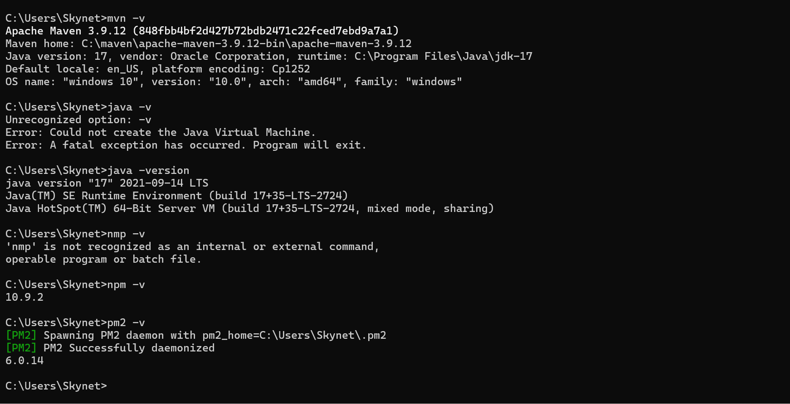

Solution 1:-

Step 1 — SSH into server
eb ssh

Step 2 — Check if app running
Spring Boot:
ps aux | grep java
Node:
ps aux | grep node
If nothing running → app crashed

Step 3 — Check logs (MOST IMPORTANT)
eb logs
Look for:
Port error
DB connection error
Jar not found
Permission denied
Fix whatever error appears.

Step 4 — Set Correct Port (Most common issue)
Elastic Beanstalk expects app on:
PORT = 5000
Spring Boot fix → application.properties
server.port=5000
Then redeploy.

Step 5 — Confirm Procfile exists
Project root must contain:
Procfile
Spring Boot example:
web: java -jar yourapp.jar

Step 6 — Restart server
Console → Actions → Restart App Servers

Instant Diagnosis Rule
Symptom | Cause | Fix
502 + blank page | app not running | fix logs
502 after deploy | wrong port | set 5000
502 immediately | Procfile missing | add Procfile

Solution 2 : To resolve the issue, first open Google Chrome, go to Settings, and check your network or proxy configuration. Then open Run (Windows + R), launch Command Prompt, and verify that Nginx is running using:
nginx -t
(check configuration)
nginx -s reload
(restart Nginx)
If Nginx is not running, start it with:
start nginx
This ensures the server is properly configured and running.

